**Meets Specifications**

[](https://udacity-github-sync-content.s3.amazonaws.com/_attachments/38140/1475724530/you-got-this.jpg)

Congratulations on passing your exam!

**Bonus**

A partnership with Google has released an [open source software](https://research.googleblog.com/2017/07/facets-open-source-visualization-tool.html) to visualize machine learning datasets. And the best part is that they are using the same dataset of this project as live demo! If you want to perform some data visualization with the data of this project, go to the link <https://pair-code.github.io/facets/> and play around. Here’s an example from Google’s blog:

[](https://2.bp.blogspot.com/-Kab341D9VYI/WWz0NrlzH_I/AAAAAAAAB5E/BkIxG4WnADgQTmAFxLSw2zoAuPvIRw6igCLcBGAs/s640/image1.gif)

**Exploring the Data**

Student's implementation correctly calculates the following:

* Number of records
* Number of individuals with income >$50,000
* Number of individuals with income <=$50,000
* Percentage of individuals with income > $50,000

**Bonus**

We can also get some initial statistics with the pandas method [describe](https://pandas.pydata.org/pandas-docs/stable/generated/pandas.DataFrame.describe.html).

data.describe()

In addition, a very cool tool for data visualization and correlations is the pairplot of seaborn (install using pip install seaborn):

[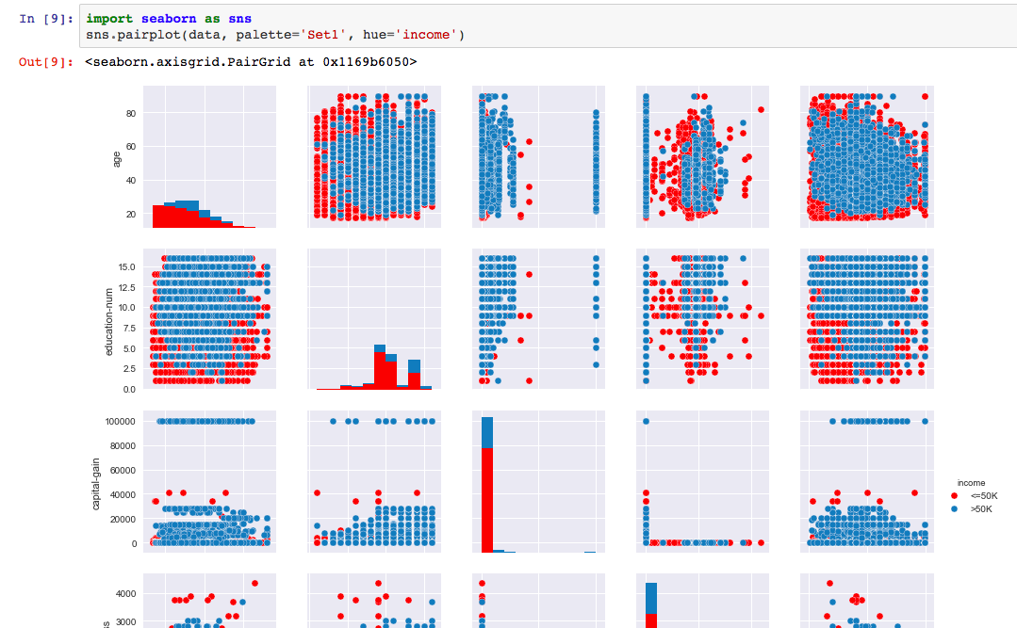](https://udacity-reviews-uploads.s3.us-west-2.amazonaws.com/_attachments/38140/1517611962/Screen_Shot_2018-02-02_at_23.52.02.png)

**Preparing the Data**

Student correctly implements one-hot encoding for the feature and income data.

Nice solution! Another alternative is to use the method apply combined with a lambda function:

income = income_raw.apply(lambda x: 1 if x=='>50K' else 0)

**Comment**

[This reference](http://www.kdnuggets.com/2015/12/beyond-one-hot-exploration-categorical-variables.html) provides 7 different encoding strategies. [Binary encoding](http://scikit-learn.org/stable/modules/generated/sklearn.preprocessing.LabelBinarizer.html) is a great choice for cases where the number of categories for a given feature is very high.

**Evaluating Model Performance**

Student correctly calculates the benchmark score of the naive predictor for both accuracy and F1 scores.

Great job calculating the accuracy and the F-score for a Naive predictor!

**Comment**

Note that the F-score is higher than the accuracy which seems counter-intuitive since the F-score is a more elaborate calculation. That happens because a value of beta = 0.5 attenuates the influence of false negatives. In other words, this value of beta weights more the positive predictions (>50K) than the negative one (<=50K).

The pros and cons or application for each model is provided with reasonable justification why each model was chosen to be explored.

Please list all the references you use while listing out your pros and cons.

**Comment**

Some further comments:

algorithm makes assumption, that features are strongly independent between each other (see The Optimality of Naive Bayes, p. 1)

That's correct! For example, Google initially had problems in searches such as the "Chicago Bulls" team would return images of bulls and the city of Chicago ([reference](https://www.youtube.com/watch?v=nfbKTrufPOs)).

high computational cost, since fit time complexity is more than quadratic (see sklearn.svm.SVC)

Alternatively there is the Stochastic Gradient Descent which implements an approximate version of Linear SVM and Logistic Regression. As advantages it is faster and supports online learning. However, it does not support the 'kernel trick' and its result is approximate.

**Bonus**

You can also refer to [this reference](https://static.coggle.it/diagram/WHeBqDIrJRk-kDDY) when choosing your estimator:

[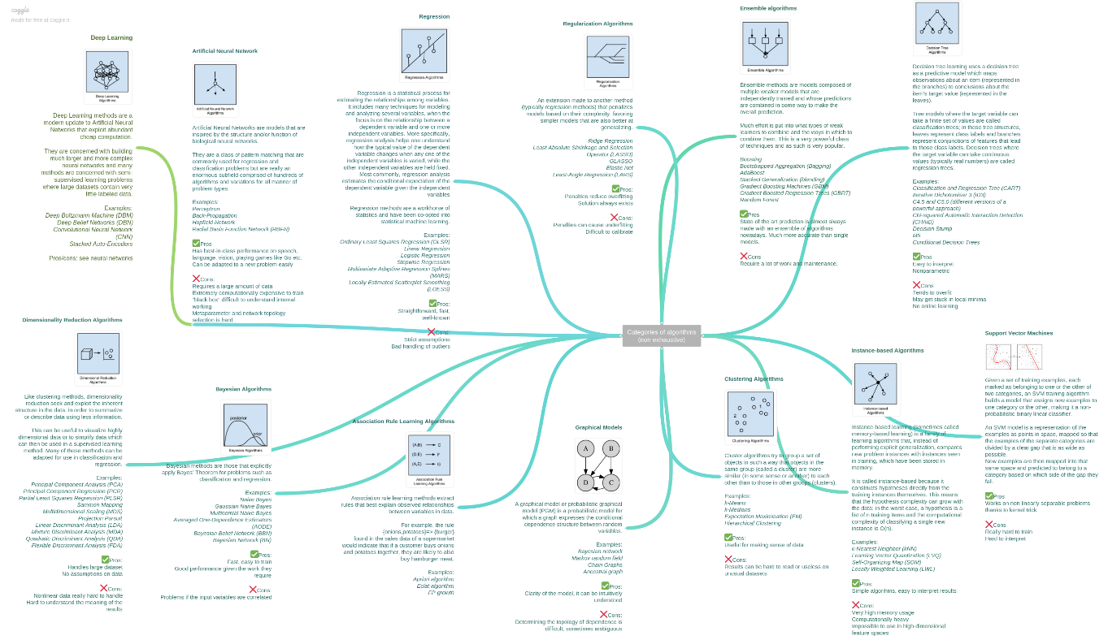](https://udacity-reviews-uploads.s3.amazonaws.com/_attachments/38140/1509378374/Categories_of_algorithmsnon_exhaustive.png)

* [This reference](http://arogozhnikov.github.io/2016/04/28/demonstrations-for-ml-courses.html) provides many visualization resources of machine learning algorithms. I definitely recommend it to get a visual intuition of ML techniques. My favorite is the article [Gradient Boosting explained](https://arogozhnikov.github.io/2016/06/24/gradient_boosting_explained.html).
* [This reference from sklearn](http://scikit-learn.org/stable/auto_examples/classification/plot_classifier_comparison.html) compares the decision boundaries of the major classifiers.
* [This map from sklearn](http://scikit-learn.org/stable/tutorial/machine_learning_map/) might be also helpful in order to give guidance when choosing an estimator.
* [XGBoost](https://en.wikipedia.org/wiki/Xgboost) and [Random Forest](https://en.wikipedia.org/wiki/Random_forest) are two very popular algorithms in data science contests. [This guide](https://www.analyticsvidhya.com/blog/2016/03/complete-guide-parameter-tuning-xgboost-with-codes-python/) might be useful for tuning XGBoost.
* Three suggestion of books in case you are interested in diving deeper into the characteristics of each estimator:
  + [The Elements of Statistical Learning](https://web.stanford.edu/~hastie/ElemStatLearn/)
  + [Bishop: Pattern Recognition and Machine Learning](http://users.isr.ist.utl.pt/~wurmd/Livros/school/Bishop%20-%20Pattern%20Recognition%20And%20Machine%20Learning%20-%20Springer%20%202006.pdf)
  + [Machine Learning - Tom Mitchell](http://personal.disco.unimib.it/Vanneschi/McGrawHill_-_Machine_Learning_-Tom_Mitchell.pdf)

Student successfully implements a pipeline in code that will train and predict on the supervised learning algorithm given.

Student correctly implements three supervised learning models and produces a performance visualization.

**Improving Results**

Justification is provided for which model appears to be the best to use given computational cost, model performance, and the characteristics of the data.

I agree with your choice of AdaBoost here! It is one of the best estimators for this project (together with Gradient Boosting). It is worth noting that it might not be fair to compare different models with their default parameters. For example, Decision Trees tend to not perform well with their default parameters while their tuned model can surpass the tuned SVM.

Student is able to clearly and concisely describe how the optimal model works in layman's terms to someone who is not familiar with machine learning nor has a technical background.

**Bonus**

This [video](https://youtu.be/k4G2VCuOMMg) shows AdaBoost in action. It might be useful to get an intuition of how this estimator works. I suggest watching it in slow motion:

[](https://udacity-reviews-uploads.s3.us-west-2.amazonaws.com/_attachments/38140/1518796521/X7SUyh.gif)

The final model chosen is correctly tuned using grid search with at least one parameter using at least three settings. If the model does not need any parameter tuning it is explicitly stated with reasonable justification.

Student reports the accuracy and F1 score of the optimized, unoptimized, models correctly in the table provided. Student compares the final model results to previous results obtained.

Awesome improvement in the model using grid search! AdaBoost and Gradient Boosting are usually the estimators with highest scores for this project (scores higher than 0.74 after tuning).

**Feature Importance**

Student ranks five features which they believe to be the most relevant for predicting an individual's’ income. Discussion is provided for why these features were chosen.

Student correctly implements a supervised learning model that makes use of the feature_importances_ attribute. Additionally, student discusses the differences or similarities between the features they considered relevant and the reported relevant features.

**Comment**

It is worth noting that each model with feature_importances_ might return different top predictive features depending on their internal algorithm implementation.

**Suggestion**

You can also use the attribute feature_importances_ from best_clf since it is already tuned so you will have a better choice of top 5 features:

importances = best_clf.feature_importances_

**Bonus**

Besides the feature importance, an alternative is to use calculate the significance of each feature using the weights of a Logistic Regression (LR) model. The significance is calculated dividing the coefficients of the LR by their standard errors (also know as Z-score). You can check more details in the Chapter 4.4.2 of [The Elements of Statistical Learning](https://web.stanford.edu/~hastie/ElemStatLearn/). According to the reference, a Z-score higher than 2 is significant at the 5% level.

Student analyzes the final model's performance when only the top 5 features are used and compares this performance to the optimized model from **Question 5**.

**Comment**

An alternative strategy for reducing the number of features is to use dimensionality reduction techniques (PCA for example). Then, we could pick only the top descriptive features for training the model. You will see more details about PCA in the next module.